# **Yacht-Master 42**

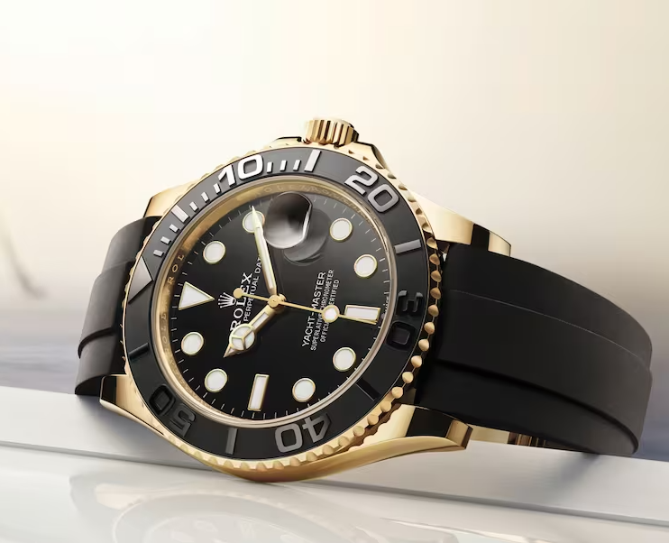Oyster, 42mm, yellow gold Reference 226658

## The Oyster Perpetual Yacht-Master 42 in 18 ct yellow gold with a black dial and an Oysterflex bracelet.

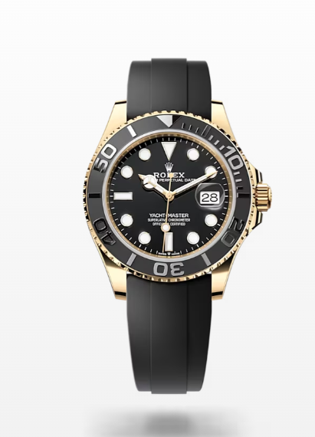

## **The Oysterflex Bracelet**

### **Highly resistant and durable:**

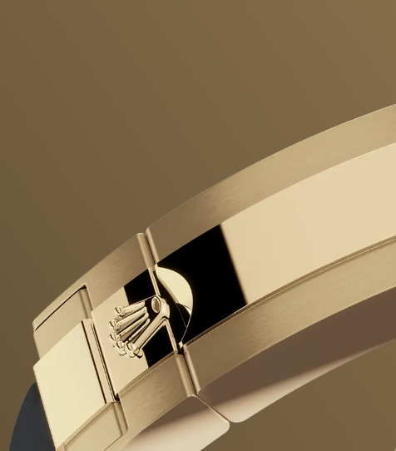The Yacht-Master’s new Oysterflex bracelet, developed by Rolex and patented, offers a sporty alternative to metal bracelets. The bracelet attaches to the watch case and the Oysterlock safety clasp by a flexible titanium and nickel alloy metal blade.

The blade is overmoulded with high-performance black elastomer which is particularly resistant to environmental effects, very durable and perfectly inert for the wearer of the watch. For enhanced comfort, the inside of the Oysterflex bracelet is equipped with a patented longitudinal cushion system that stabilizes the watch on the wrist and fitted with an 18 ct yellow gold Oysterlock safety clasp. It also features the Rolex Glidelock extension system, designed by the brand and patented. This inventive toothed mechanism, integrated beneath the clasp, allows fine adjustment of the bracelet length by some 15 mm in increments of approximately 2.5 mm, without the use of tools.

## **18 ct yellow gold**

### **Commitment to excellence:**

By operating its own exclusive foundry, Rolex has the unrivalled ability to cast the highest quality 18 ct gold alloys. According to the proportion of silver, copper, platinum or palladium added, different types of 18 ct gold are obtained: yellow, pink or white.

They are made with only the purest metals and meticulously inspected in an in-house laboratory with state-of-the-art equipment, before the gold is formed and shaped with the same painstaking attention to quality. Rolex's commitment to excellence begins at the source.